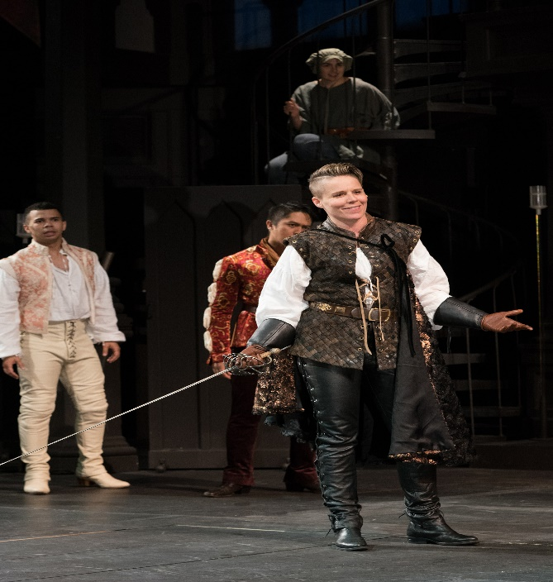

**Summary: Act 1, scene 1 notes**

Sampson and Gregory, two servants of the house of Capulet, stroll through the streets of Verona. With bawdy banter, Sampson vents his hatred of the house of Montague. The two exchange punning remarks about physically conquering Montague men and sexually conquering Montague women. Gregory sees two Montague servants approaching, and discusses with Sampson the best way to provoke them into a fight without breaking the law. Sampson bites his thumb at the Montagues—a highly insulting gesture. A verbal confrontation quickly escalates into a fight. Benvolio, a kinsman to Montague, enters and draws his sword in an attempt to stop the confrontation. Tybalt, a kinsman to Capulet, sees Benvolio’s drawn sword and draws his own. Benvolio explains that he is merely trying to keep the peace, but Tybalt professes a hatred for peace as strong as his hatred for Montagues, and attacks. The brawl spreads. A group of citizens bearing clubs attempts to restore the peace by beating down the combatants. Montague and Capulet enter, and only their wives prevent them from attacking one another. Prince Escalus arrives and commands the fighting stop on penalty of torture. The Capulets and Montagues throw down their weapons. The Prince declares the violence between the two families has gone on for too long, and proclaims a death sentence upon anyone who disturbs the civil peace again. He says that he will speak to Capulet and Montague more directly on this matter; Capulet exits with him, the brawlers disperse, and Benvolio is left alone with his uncle and aunt, Montague and Lady Montague.

Benvolio describes to Montague how the brawl started. Lady Montague asks whether Benvolio has seen her son, Romeo. Benvolio replies that he earlier saw Romeo pacing through a grove of sycamores outside the city; since Romeo seemed troubled, Benvolio did not speak to him. Concerned about their son, the Montagues tell Benvolio that Romeo has often been seen melancholy, walking alone among the sycamores. They add that they have tried to discover what troubles him, but have had no success. Benvolio sees Romeo approaching, and promises to find out the reason for his melancholy. The Montagues quickly depart.

Benvolio approaches his cousin. With a touch of sadness, Romeo tells Benvolio that he is in love with Rosaline, but that she does not return his feelings and has in fact sworn to live a life of chastity. Benvolio counsels Romeo to forget her by gazing on other beauties, but Romeo contends that the woman he loves is the most beautiful of all. Romeo departs, assuring Benvolio that he cannot teach him to forget his love. Benvolio resolves to do just that.

[**Read a translation of Act 1, scene 1 →**](https://www.sparknotes.com/nofear/shakespeare/romeojuliet/page_4/)

**Analysis**

In an opening full of rousing action that is sure to capture the audience’s attention (and designed partly for that purpose), Shakespeare provides all the background information needed to understand the world of the play. In the brawl, he portrays all of the layers of Veronese society, from those lowest in power, the servants, to the Prince who occupies the political and social pinnacle. He further provides excellent characterization of Benvolio as thoughtful and fearful of the law, Tybalt as a hothead, and Romeo as distracted and lovelorn, while showing the deep and long-standing hatred between the Montagues and Capulets. At the same time, Shakespeare establishes some of the major themes of the play. The opening of *Romeo and Juliet* is a marvel of economy, descriptive power, and excitement.

The origin of the brawl, rife as it is with sexual and physical bravado, introduces the important theme of masculine honor. Masculine honor does not function in the play as some sort of stoic indifference to pain or insult. In Verona, a man must defend his honor whenever it is transgressed against, whether verbally or physically. This concept of masculine honor exists through every layer of society in Verona, from the servants on up to the noblemen. It animates Samson and Gregory as much as it does Tybalt.

It is significant that the fight between the Montagues and Capulets erupts first among the servants. Readers of the play generally focus on the two great noble families, as they should. But do not overlook Shakespeare’s inclusion of servants in the story: the perspectives of servants in *Romeo and Juliet* are often used to comment on the actions of their masters, and therefore, society. When servants appear in the play, don’t just dismiss them as props meant to make the world of *Romeo and Juliet* look realistic. The things servants say often change the way we can look at the play, showing that while the Montagues and Capulets are gloriously tragic, they are also supremely privileged and stupid, since only the stupid would bring death upon themselves when there is no need for it. The prosaic cares of the lower classes display the difficulty of their lives; a difficulty that the Capulets and Montagues would not have to face were they not so blinded by honor and hatred.